Power bi and snowflake connection and visualization

Connecting the snowflake with power bi
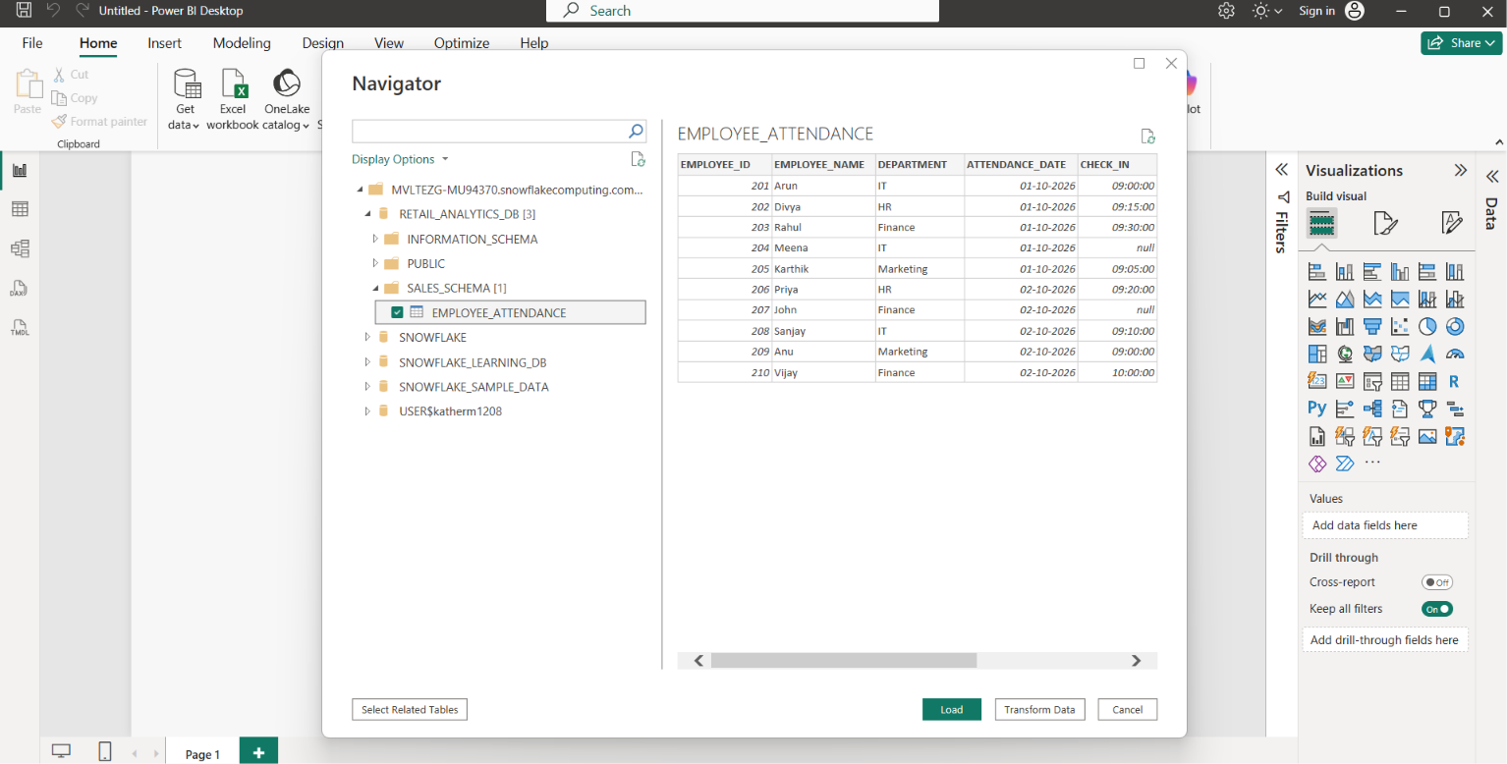

Import the data
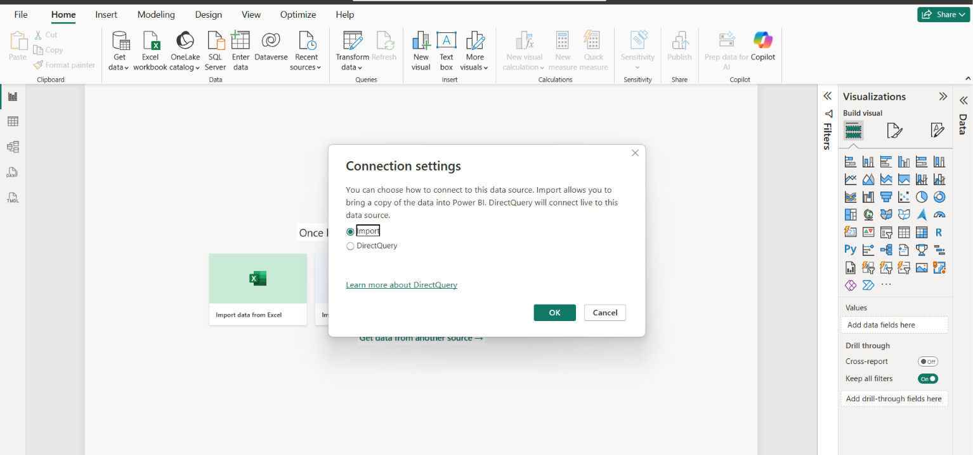

In the transform tab after doing the transformations close and apply
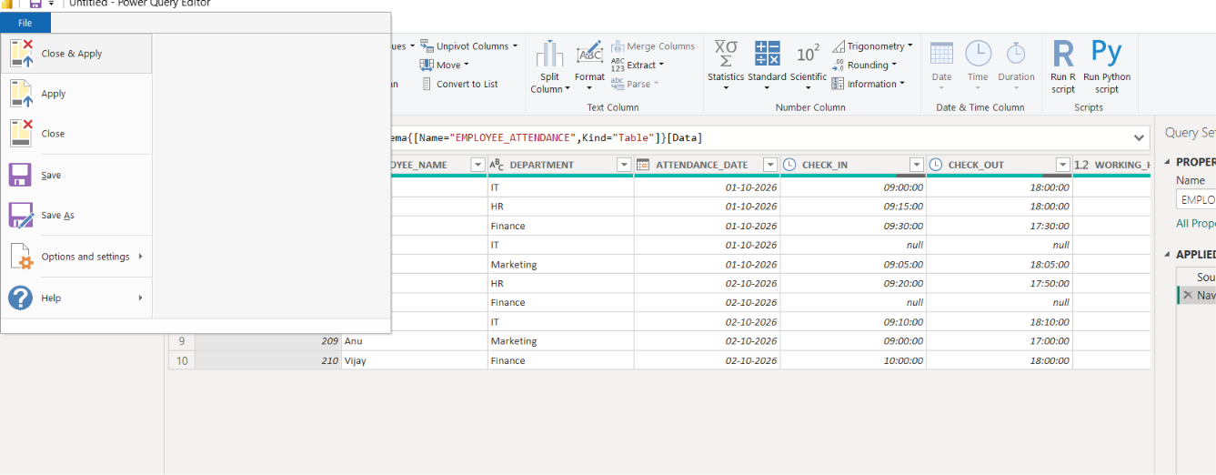

In visualization enable format filter then goto genral and on title
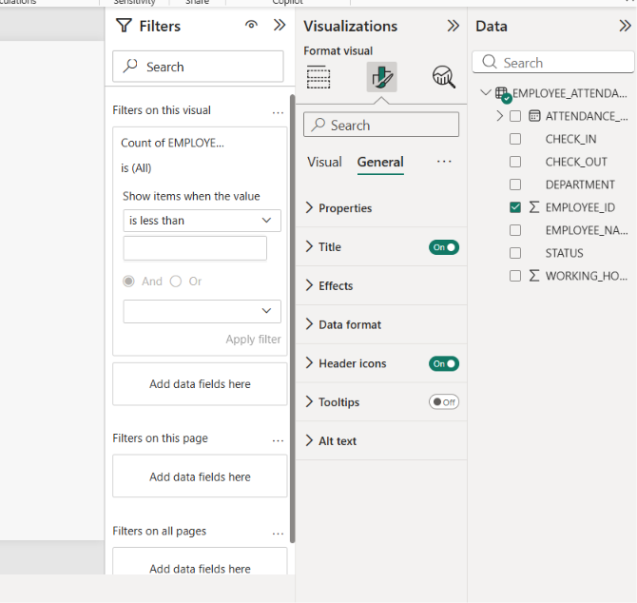

Sample visualizartions
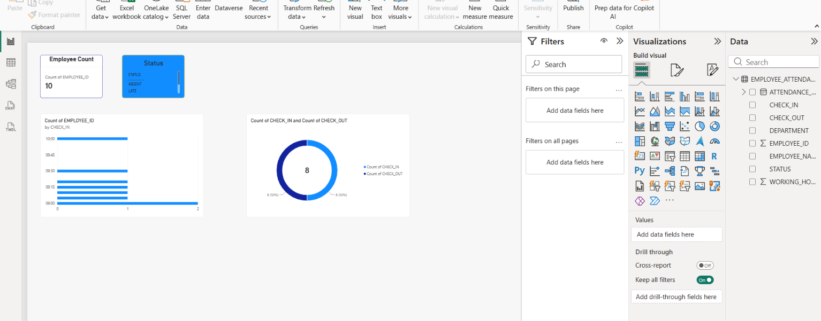

Sample playaround of the visualisations


